Test Case: tc001_SPX_Dev5_Consulta_Administracion_Accesos
Step 1 - Enter username and password and click to button Enter : Credentials Entered
Image file-name: QC_Testing-tc001_SPX_Dev5_Consulta_Administracion_Accesos-dic. 26 2025, 03 41 10 p. m.

Image file-name: QC_Testing-tc001_SPX_Dev5_Consulta_Administracion_Accesos-dic. 26 2025, 03 41 11 p. m.

Step 2 - Select to UEN and Access to Administraci�n de Accesos: UEN Correctly selected and Correct access
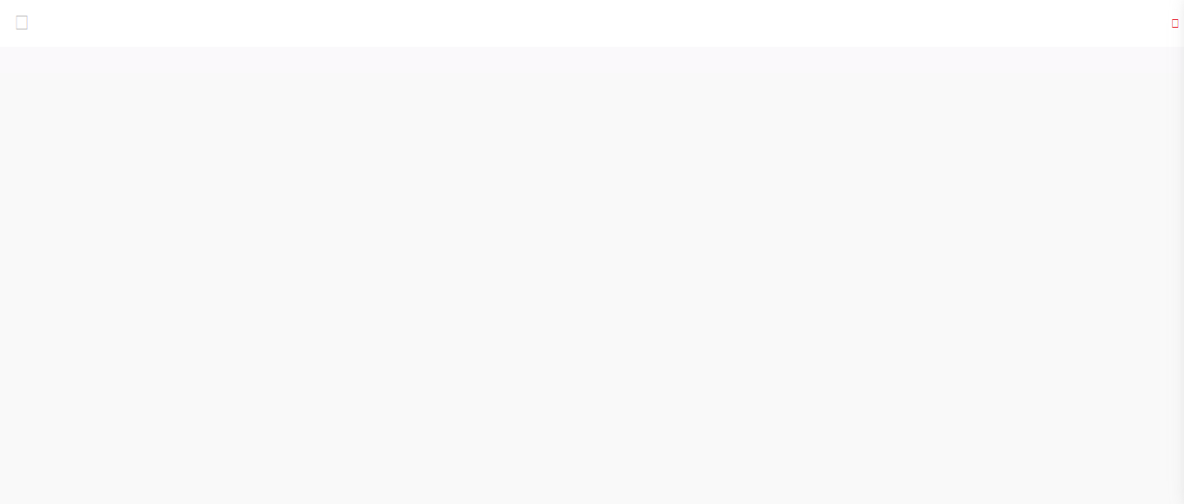Image file-name: QC_Testing-tc001_SPX_Dev5_Consulta_Administracion_Accesos-dic. 26 2025, 03 41 20 p. m.

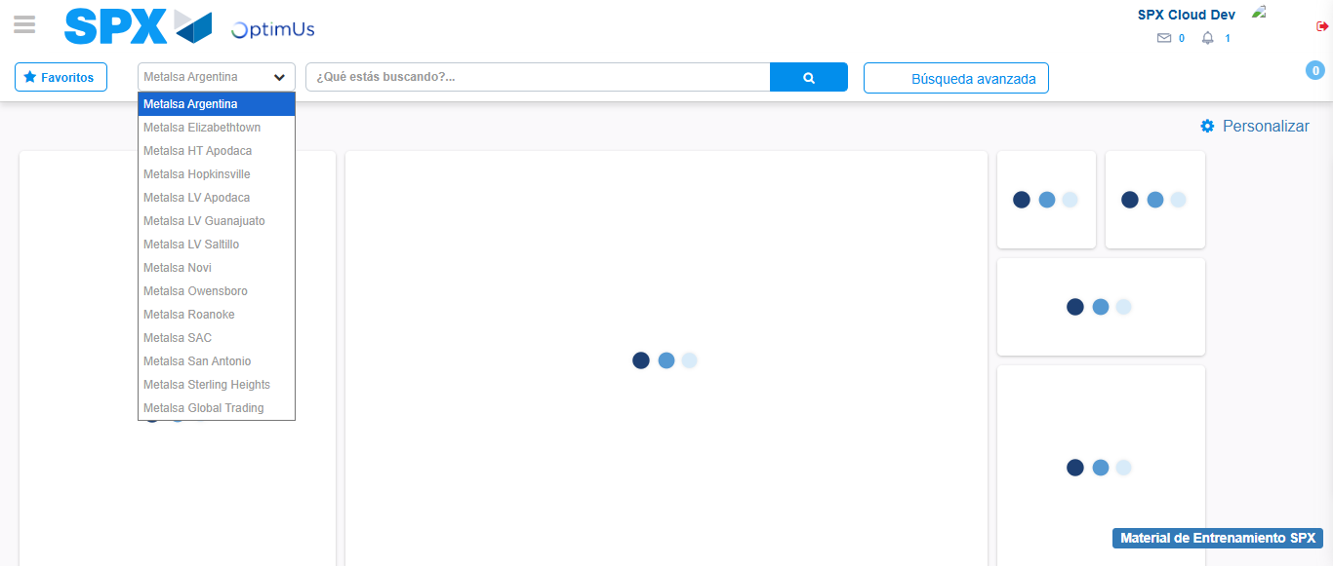Image file-name: QC_Testing-tc001_SPX_Dev5_Consulta_Administracion_Accesos-dic. 26 2025, 03 41 22 p. m.

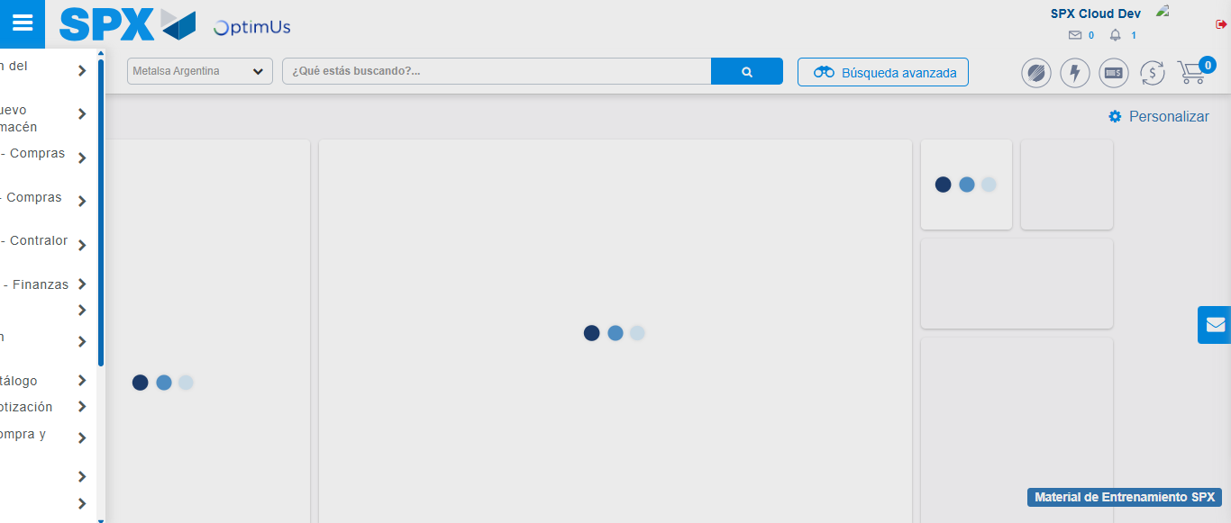Image file-name: QC_Testing-tc001_SPX_Dev5_Consulta_Administracion_Accesos-dic. 26 2025, 03 41 23 p. m.

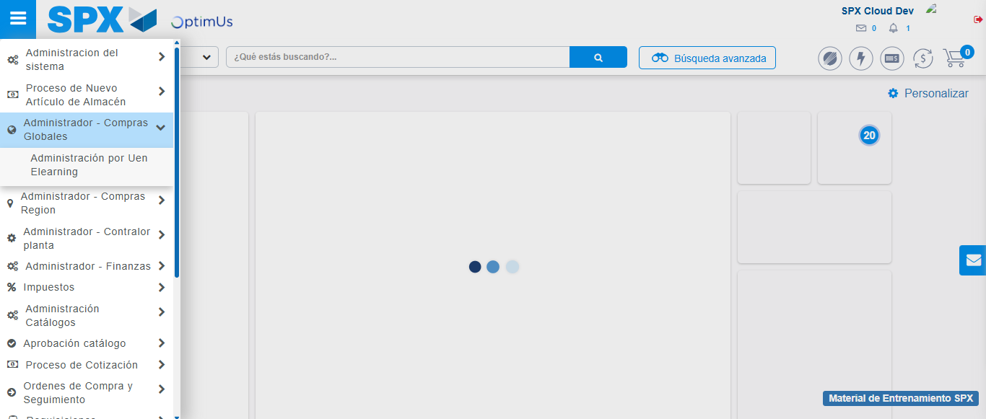Image file-name: QC_Testing-tc001_SPX_Dev5_Consulta_Administracion_Accesos-dic. 26 2025, 03 41 24 p. m.

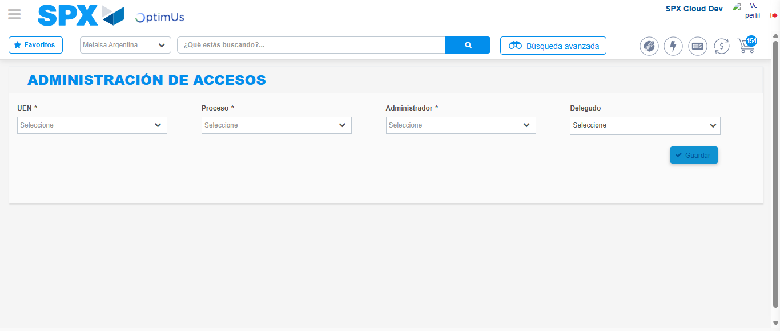Image file-name: QC_Testing-tc001_SPX_Dev5_Consulta_Administracion_Accesos-dic. 26 2025, 03 41 31 p. m.

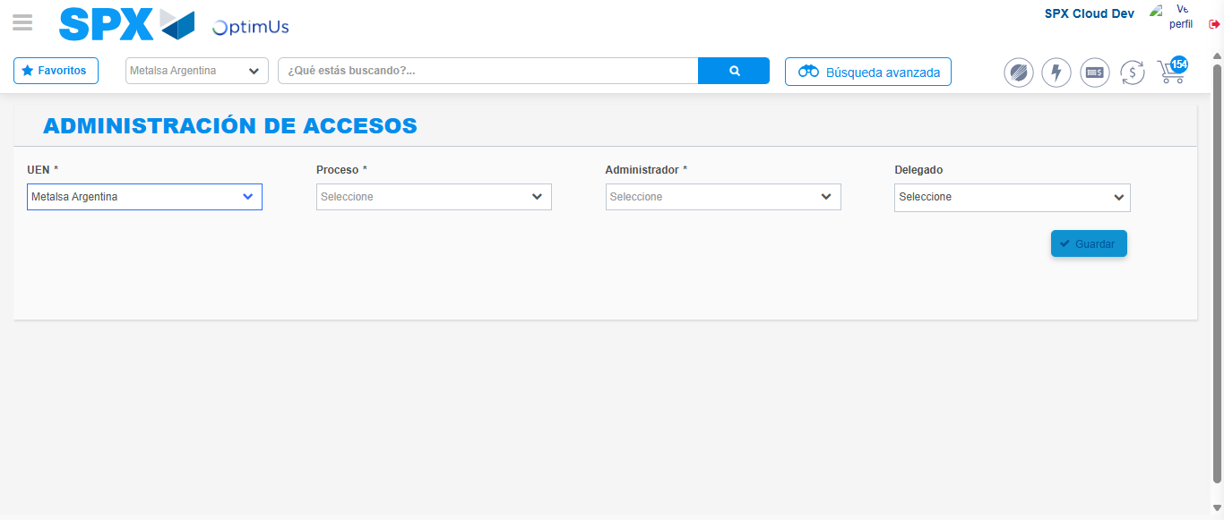Image file-name: QC_Testing-tc001_SPX_Dev5_Consulta_Administracion_Accesos-dic. 26 2025, 03 41 32 p. m.

Step 3 - Review information on Aprobaci�n Catalogos: Correct Data
Image file-name: QC_Testing-tc001_SPX_Dev5_Consulta_Administracion_Accesos-dic. 26 2025, 03 41 32 p. m.

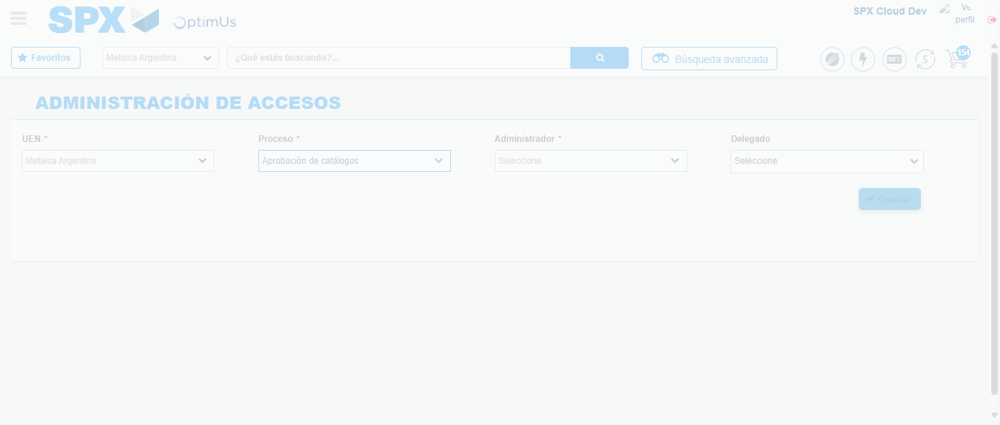Image file-name: QC_Testing-tc001_SPX_Dev5_Consulta_Administracion_Accesos-dic. 26 2025, 03 41 36 p. m.

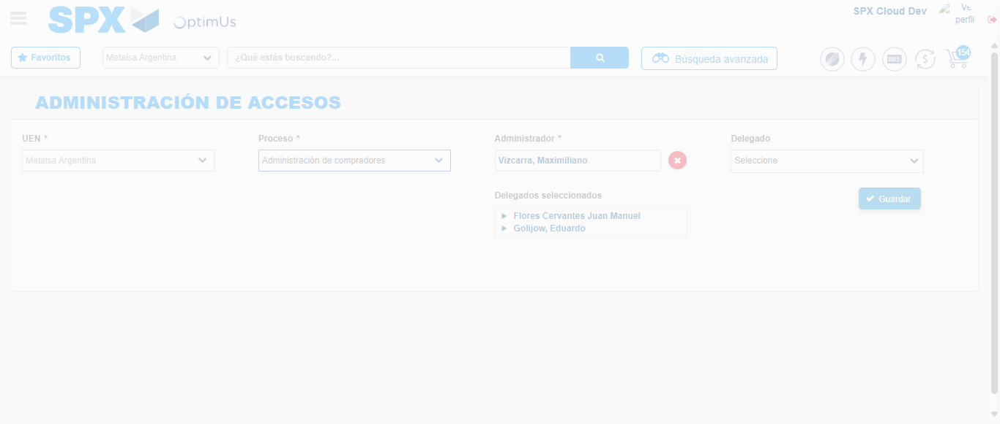Image file-name: QC_Testing-tc001_SPX_Dev5_Consulta_Administracion_Accesos-dic. 26 2025, 03 41 40 p. m.

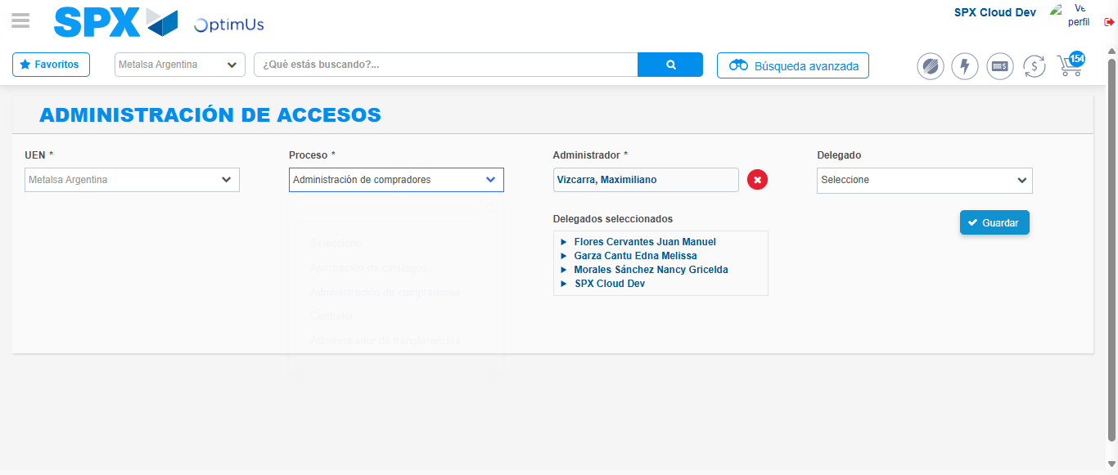Image file-name: QC_Testing-tc001_SPX_Dev5_Consulta_Administracion_Accesos-dic. 26 2025, 03 41 43 p. m.

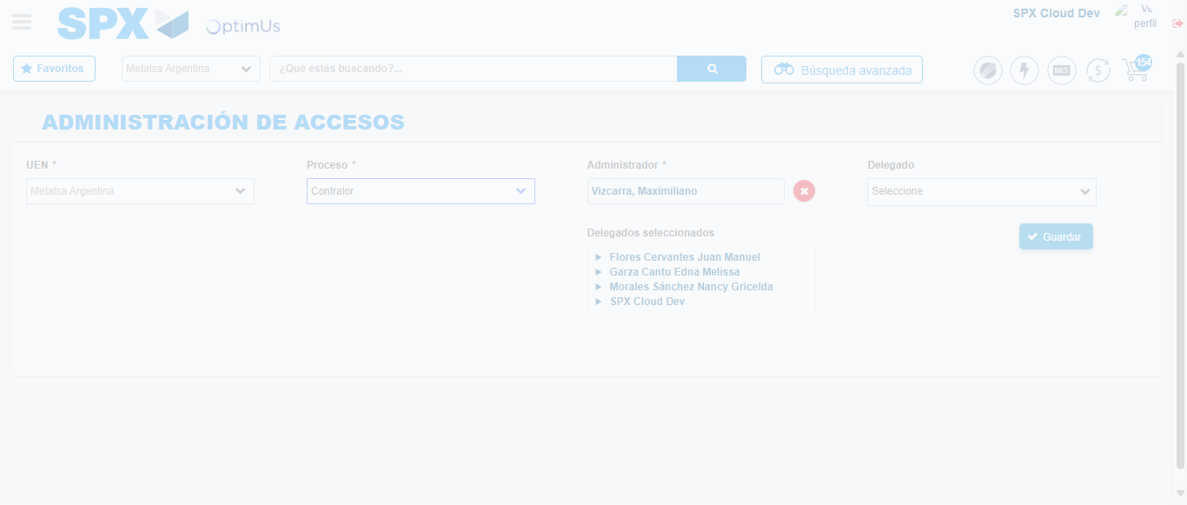Image file-name: QC_Testing-tc001_SPX_Dev5_Consulta_Administracion_Accesos-dic. 26 2025, 03 41 44 p. m.

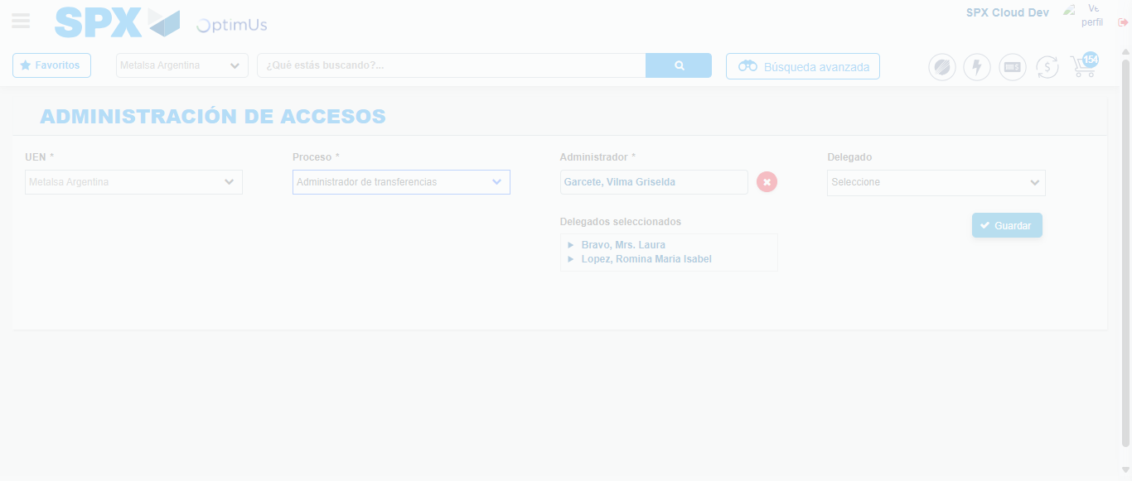Image file-name: QC_Testing-tc001_SPX_Dev5_Consulta_Administracion_Accesos-dic. 26 2025, 03 41 47 p. m.

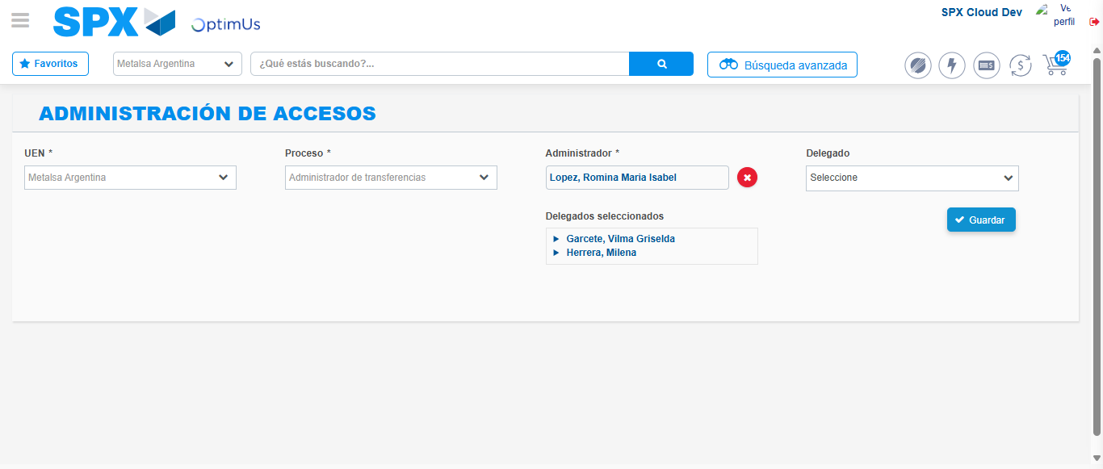Image file-name: QC_Testing-tc001_SPX_Dev5_Consulta_Administracion_Accesos-dic. 26 2025, 03 41 51 p. m.

